++++++++++++*

player (player_id, pname,speciality,date_of joining,num_matches,team_id)

team(team_id, tname,player_num)

matches(match_id, team1_id,team2_id,match_date,winner,man_of_the match)

simple query

1. display all players playerid, player name and experience

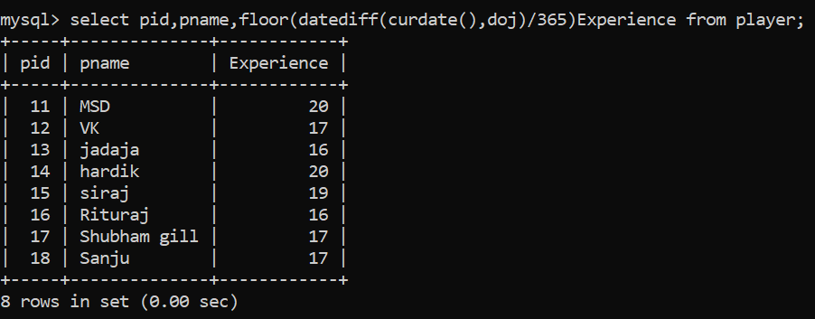

1. display all player with experience > 5 years

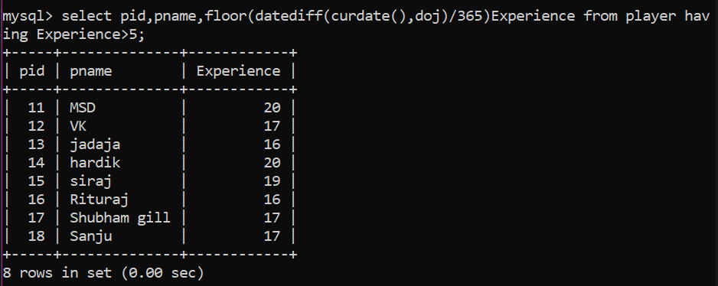

1. display all players joined in february month, any year
2. 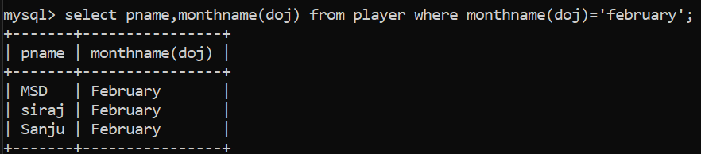

1. display all players joined in may 2007

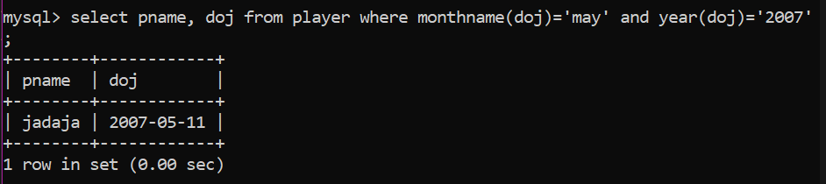

1. display all player with number of matches played are either 5 or 10 or 8 (289,98,87)
2. 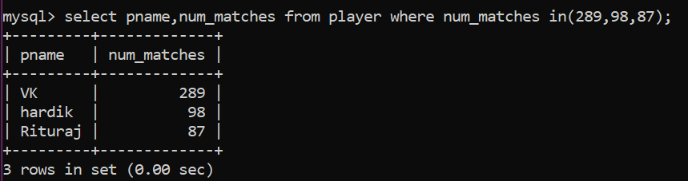
3. display all employees who are either batsman, bowler

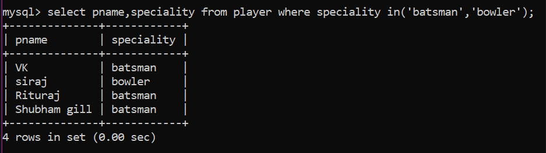

1. display all employees who joined in year 1995 or 1996 or 1997 (2004,2005,2006)

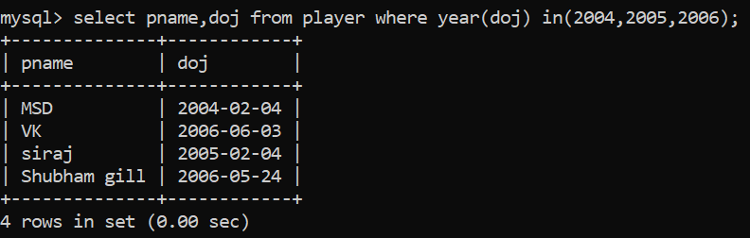

**Nested query :**

1. list all player who plays in virat kohalis team

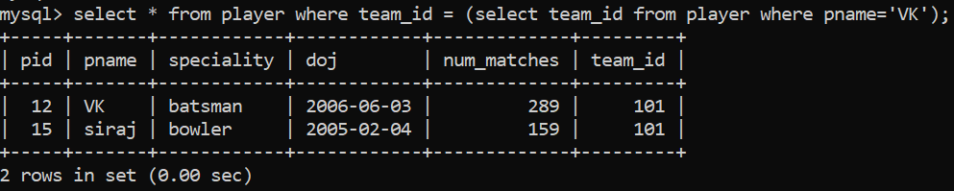

2. list all players who played matches in year 2024

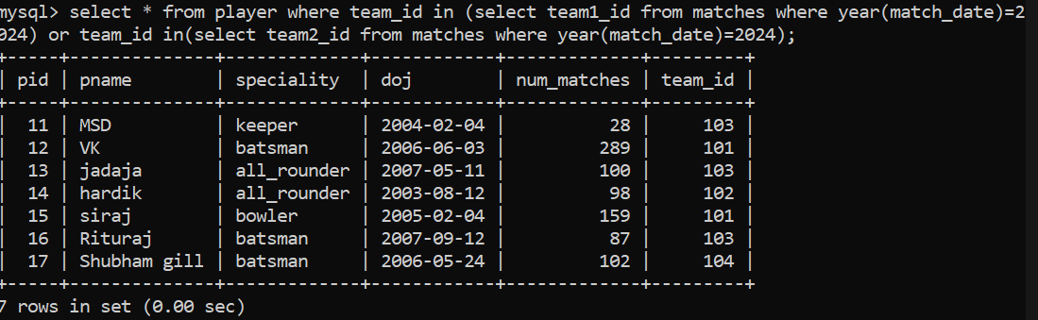

1. list all matches in which man of the match is from team1

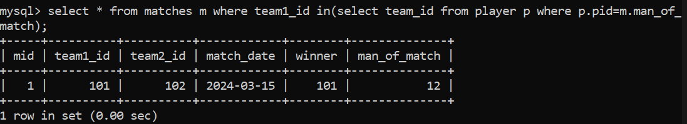

1. list all matches in which man of the match is from team2

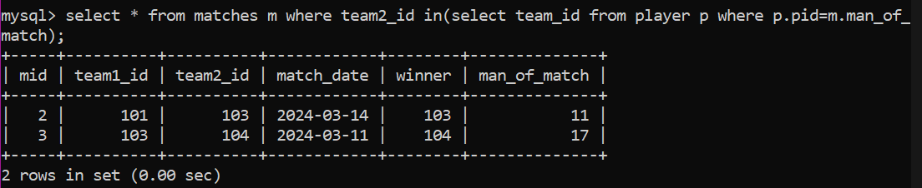

1. list all matches in which csk team win.

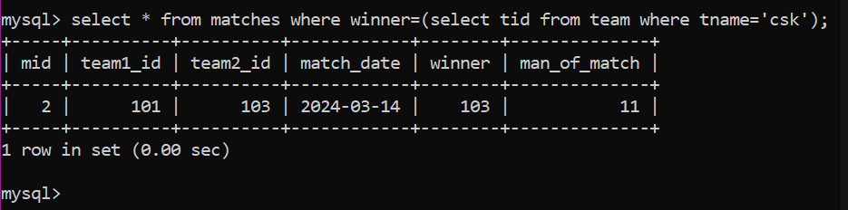

1. list all matches in which either csk or rcb team won the match

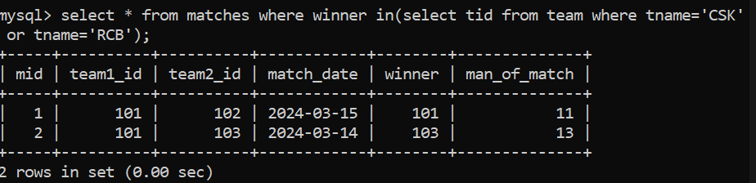

1. list all teams who won atleast one match

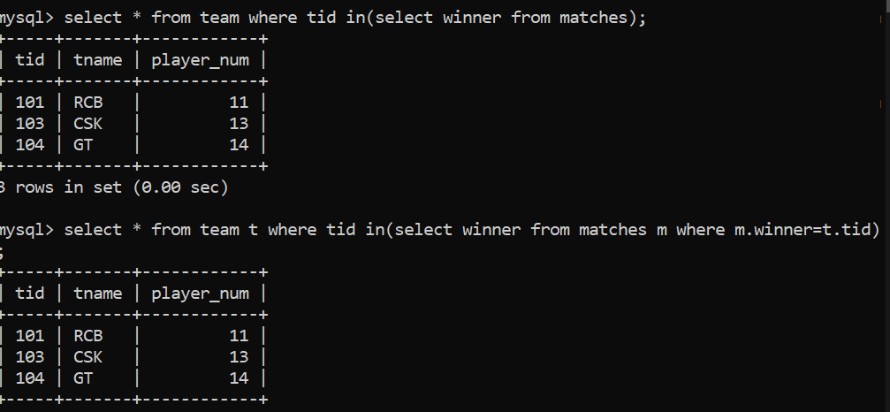

1. list all teams who does not played any match

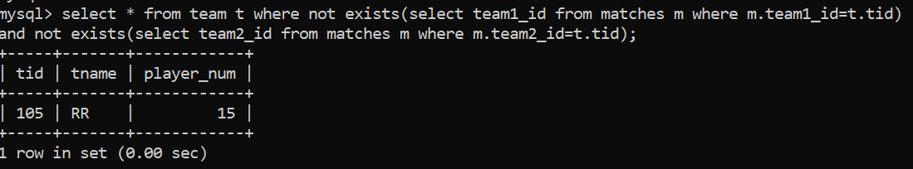

1. list all team name, in which no players are their

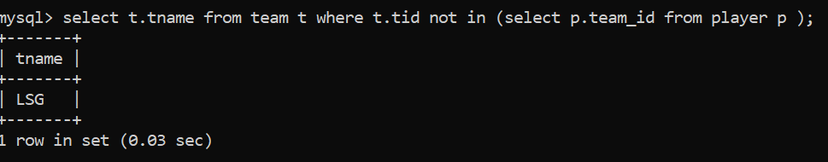

1. list all players who are in dhoni’s team

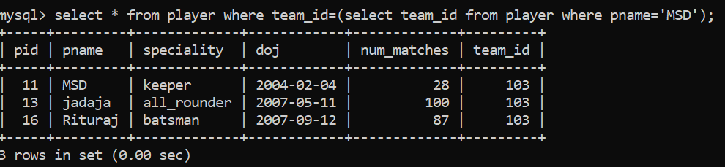

1. list all players who are in either dhoni’s or virat’s team

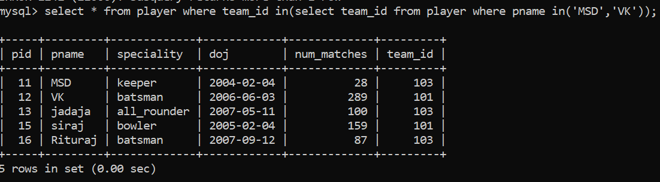

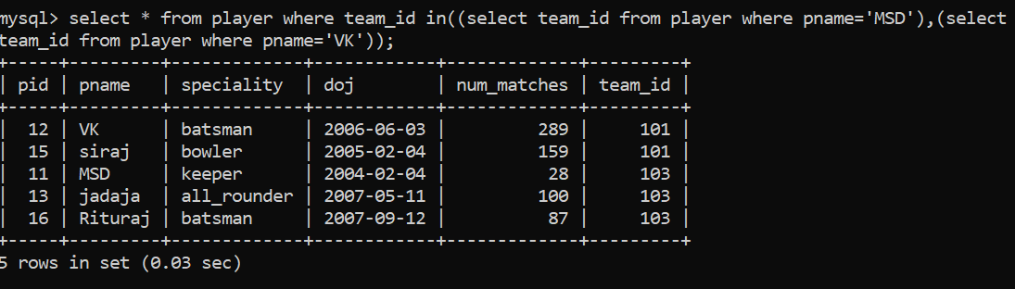

1. find all team names who won more than 3 matches

